**COLONIAL NEWS**

Health Committee Newsletter MAY 2024

Welcome to the Albert Gallatin School District Health Committee’s monthly newsletter. Each month this publication will provide our district with health and fitness information. Our goal is for our students, families, and staff to use this information to make healthy decisions and to live a healthy active lifestyle.

**back to school**

It will be here before you know it. Here are some tips to help you and your child transition from summer break to back to school:

* **Help your child adjust to earlier bedtimes a week or two before the new school year** starts.
* **Point out the positive aspects of school starting**to help your child look forward to the first day of class. Talk about how they will see old friends and meet new ones, for example.
* Attend orientations and take an opportunity to tour the school. This is especially helpful for those students entering Kindergarten, Grade 6 and Grade 9.
* Create a morning routine prior to the start of the school year by doing things such as waking up at the same time every day, eating a nutritious breakfast, and getting school supplies and backpack ready the night before.
* Schedule a well-child visit with your healthcare provider. Address and plan for health concerns or potential problems before the school year starts. Make sure your child is up to date on all recommended immunizations.



Adapted from Sources: <https://www.uchealth.com/> and <https://www.healthychildren.org/>

## **Summer!**

Summer is right around the corner and it is a season of good times outdoors. Knowledge and simple preparations are key to enjoying those outdoor activities. Here are a few tips help you:

* Stay Hydrated – The general recommendation for the average adult is 8 eight-ounce glasses of water per day. However, everyone’s needs are different depending on their activity level. Many fruits and vegetables, such as cucumbers, lettuce, broccoli, strawberries and watermelon, have a high-water content and can contribute to hydration.
* Bites and Stings – To avoid bites and stings: Stay away from wooded areas, tall grass and piles of leaves where moisture gets trapped. Wear light-colored clothing, long sleeves, pants and closed shoes. Use insect repellent. Keep hair tied back or tucked into a hat. Do a full body check and shower within 2 hours of being outdoors.
* Water Safety – Make learning to swim a priority. Always stay with a friend or family member. Avoid horseplay and diving into shallow water. Wear a life jacket when boating.
* Sun Protection – Use a broad-spectrum sunscreen that blocks both UVA and UVB rays and has an SPF of 15 or higher. Reapply sunscreen after more than two hours and after swimming, sweating or drying off. Wearing a hat with a broad brim, seeking shade, and wearing long sleeve-shirts and pants are other ways to help protect yourself.

Have a safe and enjoyable summer!

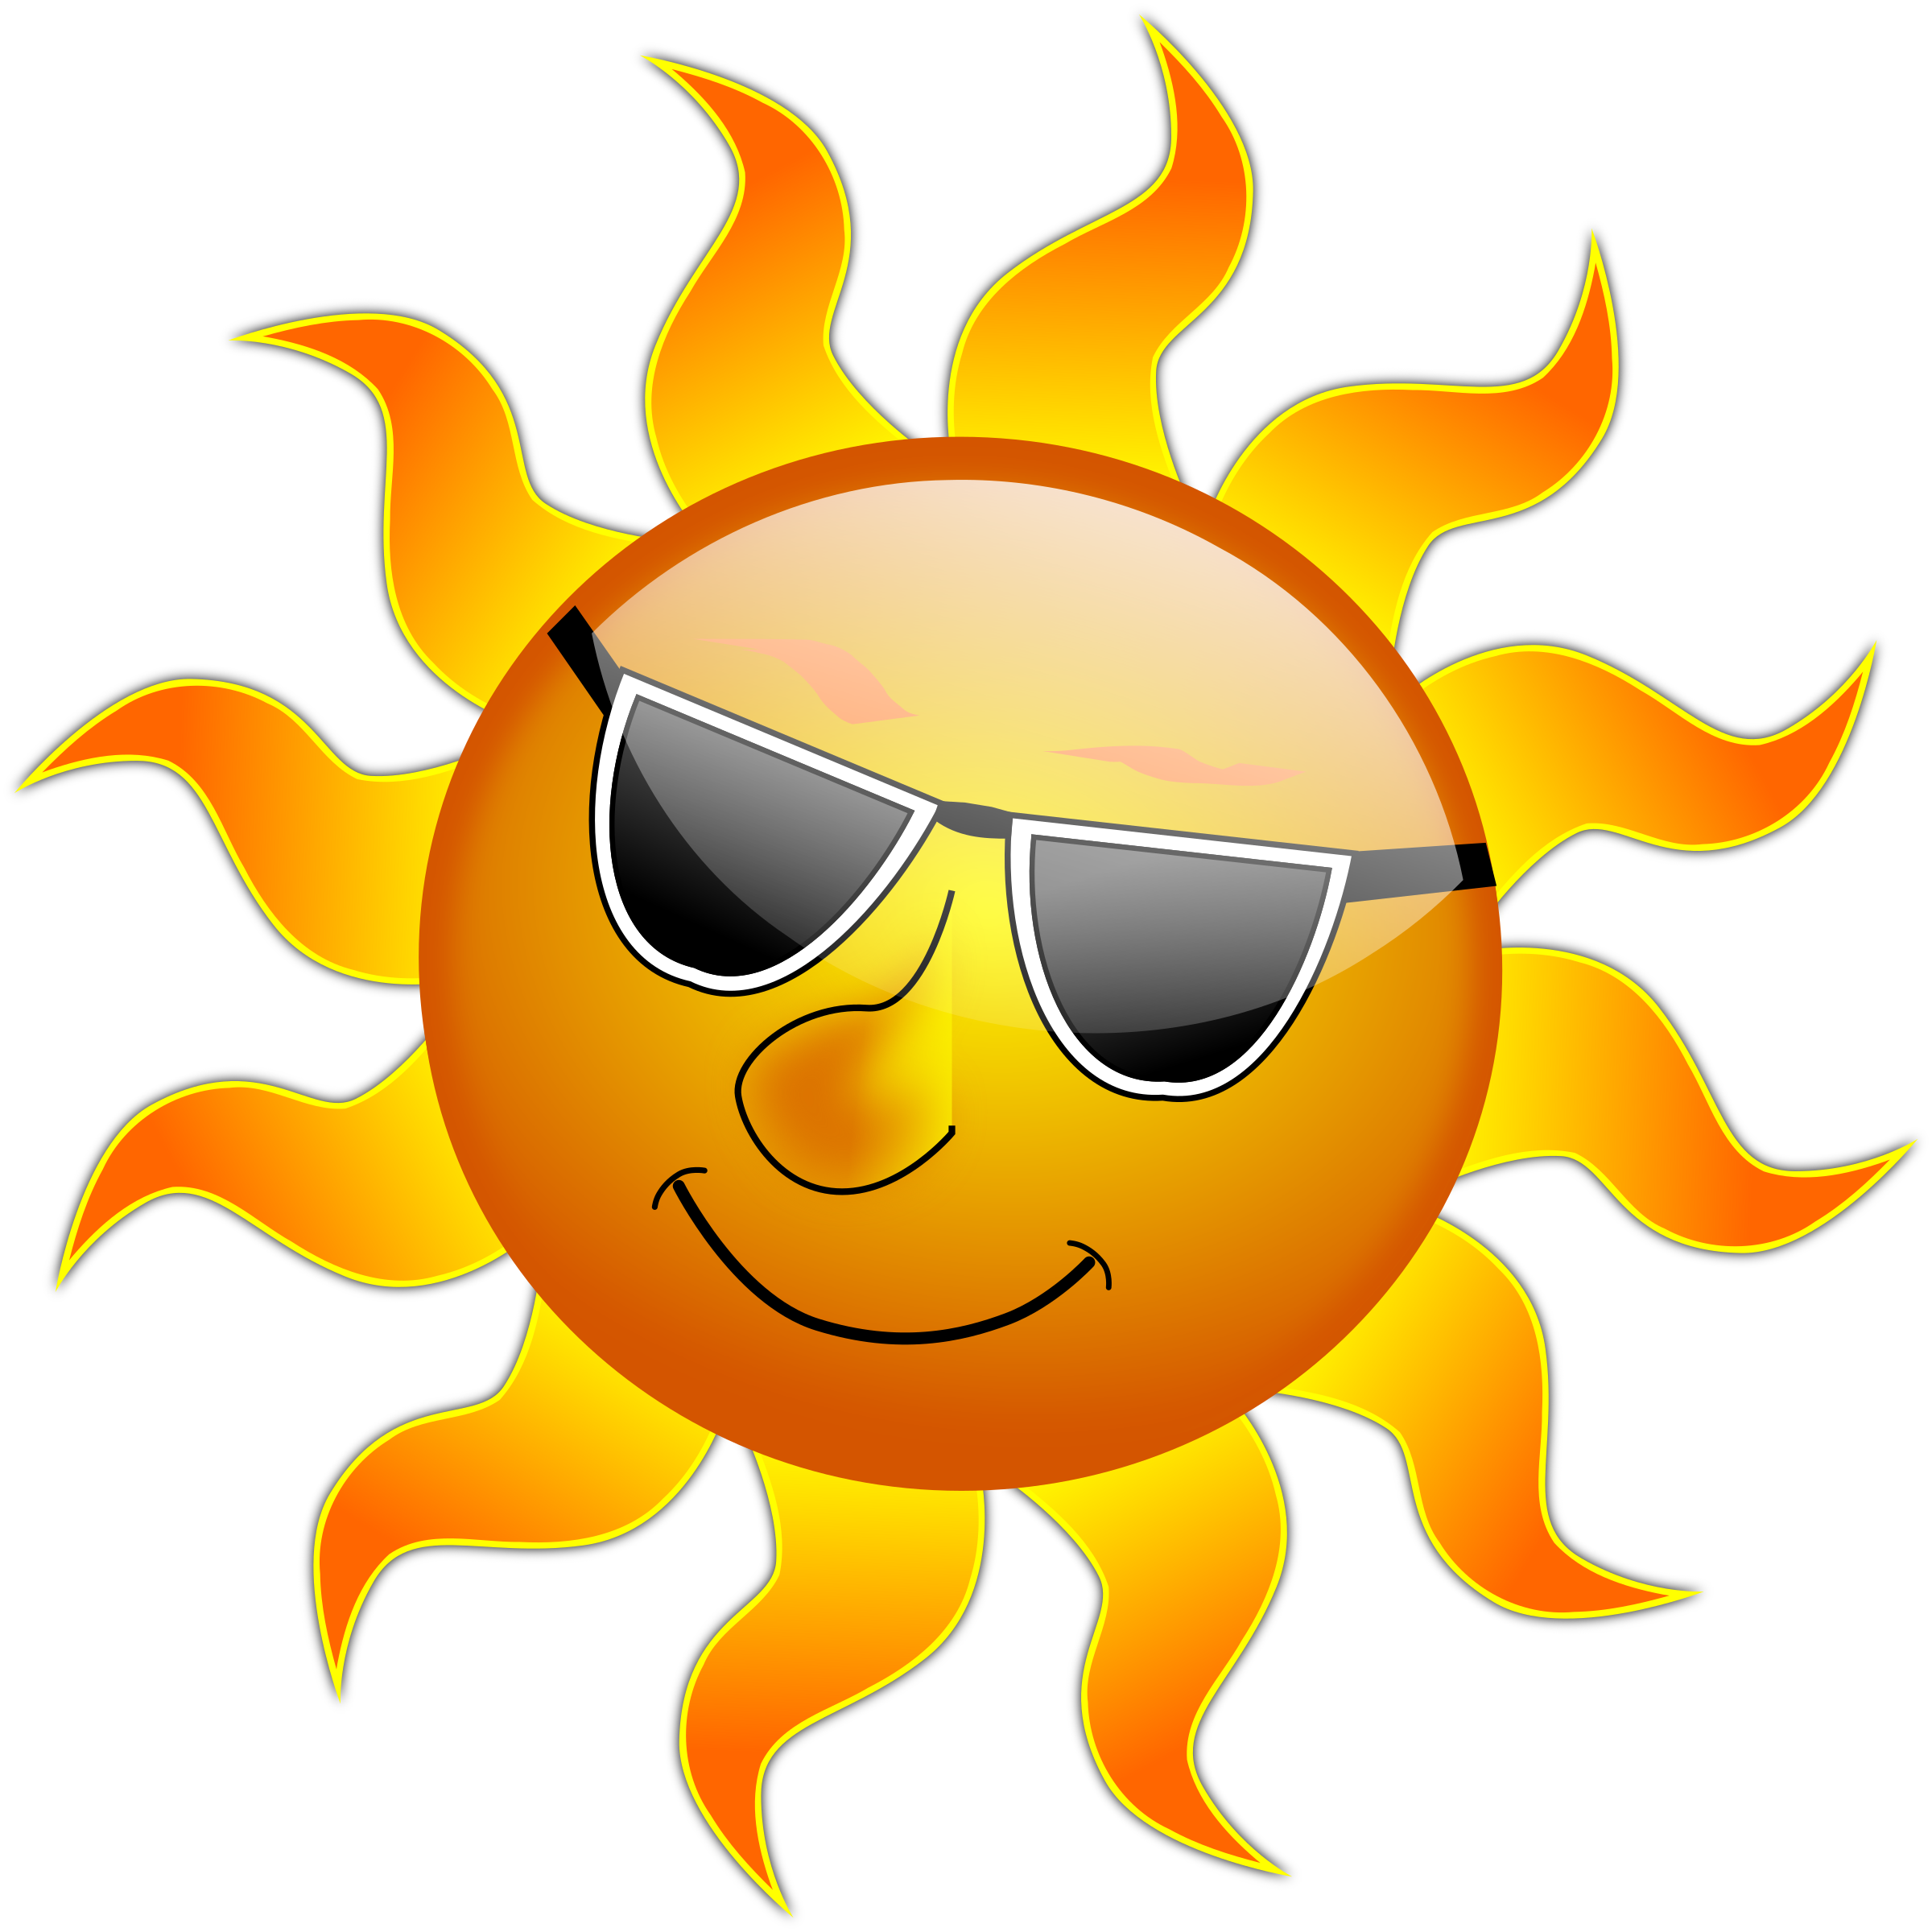

Adapted from Sources: <https://communityhealthmagazine.com> and <https://www.templehealth.org/>

Prepared by Lisa Sumey, Central Office Secretary

**Recipe of the Month**

## **YOGURT BARK**

### INGREDIENTS

* 1 1/2 cup Greek Yogurt
* 2 tbsp cream cheese (optional)
* 1/2 cup strawberries, sliced lengthwise
* handful raspberries or blueberries
* 1 tsp vanilla
* 1 1/2 Tbsp honey
* 3 Tbsp coconut flakes

### INSTRUCTIONS

1. Mix the cream cheese, yogurt, honey and vanilla using whisk, a blender or a food processor. Stir in 1 Tbsp coconut flakes.
2. Line a small baking pan with parchment paper and spread the yogurt mixture inside.
3. Spread out the sliced berries over the yogurt and sprinkle some coconut flakes.
4. Freeze for at least 1 hour, or until firm, cut in pieces and enjoy!

## **YOGURT BARK**

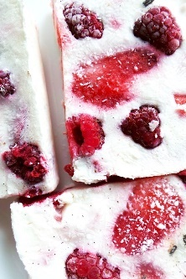

## **Healthy Banana Chocolate Chip Muffins**

   
  
  
  
   
  
 

# S t r e t c h

Stretching promotes flexibility and relaxation and can help get rid of extra tension. The following stretches can be done anywhere or anytime – at work, at home or after a workout.

**STANDING QUAD STRETCH**

* Hold onto a chair, wall, or counter top for balance as you bend one knee and grab the foot behind you.
* Squeeze your glutes and bring your stretching leg back until your thighs are even.You should feel the stretch on the front of the thigh on the bent leg.
* If this stretch is too intense, put a towel or band around your foot and gently pull the towel or band up toward your glutes to allow your knee to bend as far as you can to feel a comfortable stretch.

**Biceps Stretch**

* Sit up tall with your feet shoulder width apart.
* Take your arms out to the sides, slightly behind you, with your thumbs up
* Rotate your thumbs down and back until they are pointing to the back wall to stretch the biceps.
* Hold for 15 to 30 seconds, repeating 1 to 3 times.

*Before starting any exercise talk with your doctor to make sure they are safe for you based on your*[*fitness level*](https://www.verywellfit.com/home-fitness-tests-3120282)*and health conditions.*

Adapted from Sources: <https://blog.nasm.org/> and <https://www.verywellfit.com>

